Experiment No – 4

Title / Aim :- Use function types, scope, and closures; apply try-catch; build a palindrome checker and generate a html and js code .

Software/Tools Required :-
- Visual Studio Code (VS Code)
- Google Chrome / Any Web Browser
- HTML
- JavaScript

THEORY :-
A Palindrome Checker is a JavaScript application that determines whether a given word or sentence reads the same forward and backward after ignoring spaces, special characters, and letter case. It demonstrates string manipulation, DOM manipulation, different types of functions, scope, closures, and try...catch exception handling to provide accurate results and handle invalid input.

OUTPUT:-
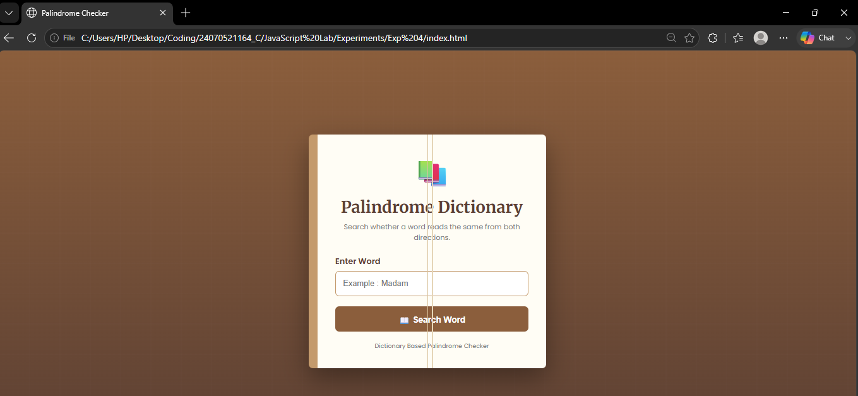

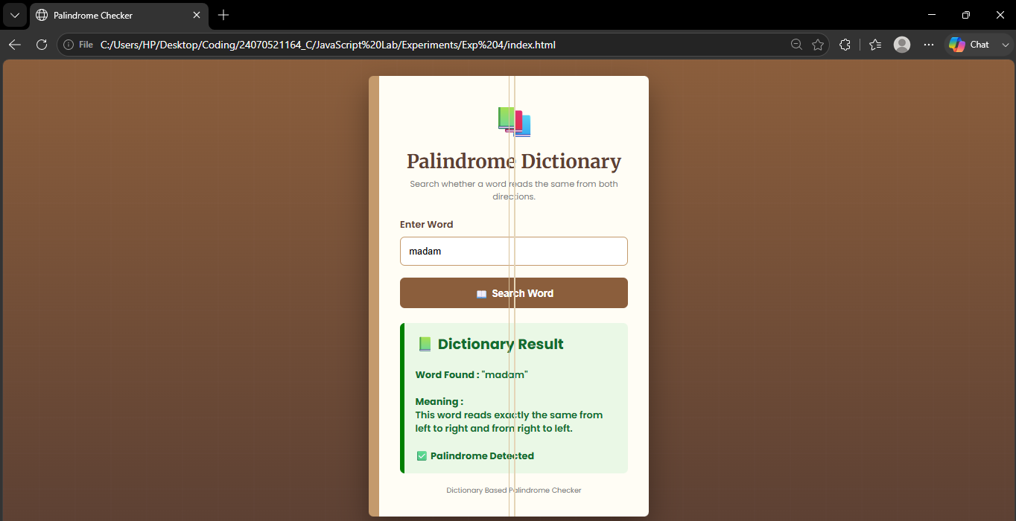
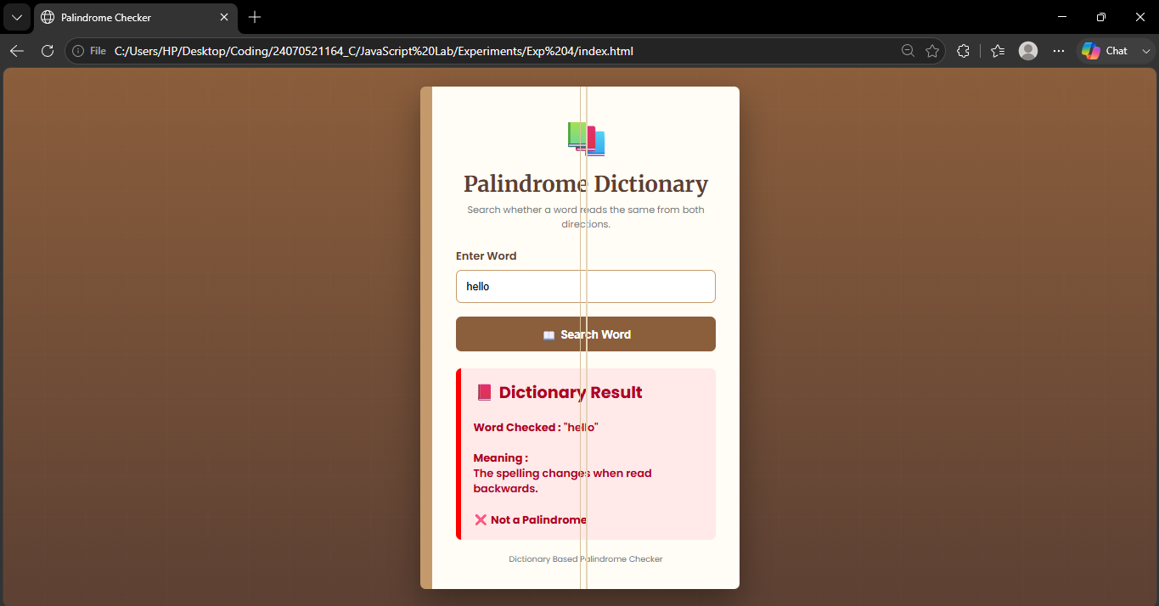
Result / Conclusion :-
The Palindrome Checker successfully identifies whether the entered text is a palindrome by comparing the original and reversed strings after preprocessing. The experiment demonstrates the use of JavaScript functions, closures, scope, and exception handling while providing an interactive and user-friendly interface.

